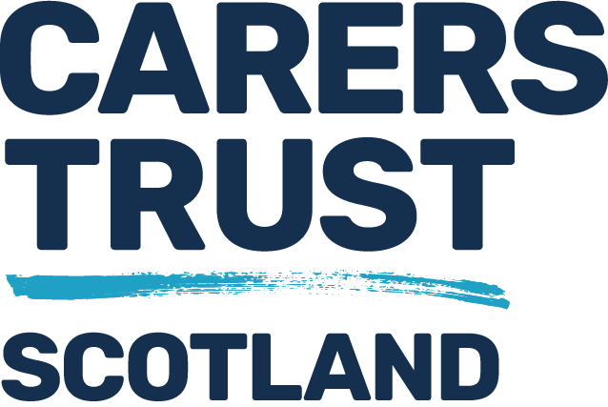

Review of Mental Health and Incapacity Legislation in Scotland
Briefing Paper – Supported Decision Making, Named Person and Role of Carers
Background
In 2019 the Minister for Mental Health appointed John Scott QC to set up an independent review of Scotland’s mental health and incapacity legislation. The key pieces being Mental Health (Care & Treatment) (Scotland) Act 2003, and Adults with Incapacity (Scotland) Act 2000.
The review team was set up by mid 2019 and comprised of two people with lived experience of using mental health services and of providing unpaid care to someone experiencing mental ill health. A third person with lived experience joined the review in 2021.
Purpose of Review
The review was tasked with reviewing the legislation currently used to look at what changes, if any, might be needed to ensure that such legislation (and so services) complies with United Nations Convention on Rights of Person’s with Disability (UNCRPD). The UNCRPD states that all persons with all types of disabilities must enjoy all human rights and fundamental freedoms. The issue for incorporating this convention is our use of the Mental Health Act and Adults with Incapacity Act since both can and do restrict someone’s liberty at times and can impact onto a person’s human rights.
The Review has set out a lot of recommendations to change these laws and is now seeking feedback from as wide a range of people as possible.
What is Supported Decision Making?
This is a way of ensuring that a person with a mental illness, learning disability, dementia, autism or cognitive impairment is able to make as many decisions about what happens to them, including receiving any medical or psychiatric care and treatment, as possible.
Some people may need help to make certain decision but be fully capable of making other types of decisions. The UNCRPD states that no one should make any decisions on behalf of another unless the person cannot make such decisions. At that point the person should be supported to make any decisions, or someone else should make the decision but only based on what they think the person would want.
Unpaid carers can play a role in supporting someone to make decisions, including decisions on care and treatment within mental health services. To read more about supported decision making please see page 44 of review consultation document, or click https://cms.mentalhealthlawreview.scot/wp-content/uploads/2022/03/Scottish-Mental-Health-Law-Review-Consultation.pdf
What Supports Are Available?
The review has identified a number of possible supports which can be provided to help someone make decisions regardless of mental disorder, learning disability, autism, dementia or acquired brain injury. These can include:
- Named Person
- Decision Supporter
- Peer support workers
- Advocacy services
- Communication aids
Why do People Need Help in Making Decisions?
When the review talks about decision making it is also talking about the ability to put the decision into action.
For many people who use health and social care services they often feel disempowered by the system and don’t always get many chances to tell services what they want, what their wishes and desires are. This can be as a result of never having learnt effective decision-making (perhaps due to a learning disability) or may have reduced or limited capacity to fully understand process and meaning of making decisions. This can be as a result of dementia or lost skills due to mental illness.
Not being given every opportunity to make even the smallest and simplest decisions can be seen as discriminatory and oppressing a person. People will need various levels of support to help them understand options, consider choices, think about consequences, make decisions and put these into action.
Supported decisions can be made at any time, but the review think it is important that a system of providing support to a person to make decisions is very important to ensure the person is fully able to participate in decisions about their life and ensure their human rights are upheld and considered.
How does this affect me as a Carer?
There may be several ways this could impact onto you as a carer. Under existing mental health legislation, there is a provision for a person to nominate a Named Person. The named person can be anyone the person trusts and would like to act in their interests, although the named person can also disagree with someone and put their own views forward on care and treatment.
In the recent past a lot of named persons have been the person’s unpaid carer or next of kin. This was changed in 2015 as a lot of carers were reporting knowing nothing about their nomination to this role and therefore not feeling comfortable with it. The review, however think that what was put in place (since 2015) has not been effective and we heard from many unpaid carers and family members who did want to take on this role, but wanted more information about it.
You do not need to be a named person however to assist someone in making decisions, but the person would need to nominate you as a supporter for the reason of helping them express and carry out their wishes and decisions.
Questions
- What do you think about the idea of someone being supported to make decisions, regardless of mental illness, learning disability, autism, dementia or brain injury?
- Do you think there should be times when a person is not allowed to make decisions, even with all the support possible? If so what are these times?
- What kind of information would you need if you wanted to become a named person of someone who supports a family member or friend to make decisions?
- What do you think about a formal, legal body, such as a court or tribunal over-ruling someone becoming a named person or decision-making supporter?
- Can you think of any other ways unpaid carers could help someone make decisions?
- What are your views on someone aged 16 and over making their own decisions, with or without support?
Remember the decisions can be about care and treatment for mental illness, learning disability etc, or can be about things like their personal finance, where to live, who to have as friends, close contacts, getting married, buying property or going into care, as well as small things like deciding what to wear, when to go to bed, what to eat etc.

Karen Martin, Mental Health Coordinator, on behalf of Carers Trust Scotland

UNCRP, more information can be found https://www.un.org/development/desa/disabilities/convention-on-the-rights-of-persons-with-disabilities.html

