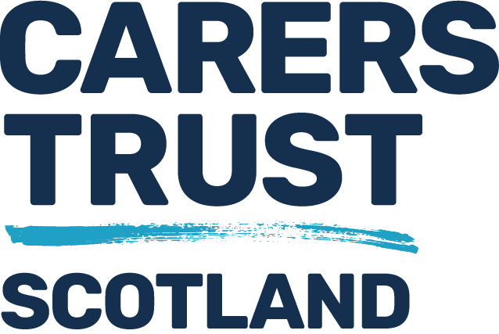

Review of Mental Health and Incapacity Legislation in Scotland
Briefing Paper – The Role of Unpaid Carers
Background
In 2019 the Minister for Mental Health appointed John Scott QC to set up an independent review of Scotland’s mental health and incapacity legislation. The key pieces being Mental Health (Care & Treatment) (Scotland) Act 2003, and Adults with Incapacity (Scotland) Act 2000.
The review team was set up by mid 2019 and comprised of two people with lived experience of using mental health services and of providing unpaid care to someone experiencing mental ill health. A third person with lived experience joined the review in 2021.
Purpose of Review
The review was tasked with reviewing the legislation currently used to look at what changes, if any, might be needed to ensure that such legislation (and so services) complies with United Nations Convention on Rights of Person’s with Disability (UNCRPD). The UNCRPD states that all persons with all types of disabilities must enjoy all human rights and fundamental freedoms. The issue for incorporating this convention is our use of the Mental Health Act and Adults with Incapacity Act since both can and do restrict someone’s liberty at times and can impact onto a person’s human rights.
The Review has set out a lot of recommendations to change these laws and is now seeking feedback from as wide a range of people as possible.
What about Unpaid Carers?
At the outset of the Review the then Minister for Mental Health stated that she expected people with lived experience, including unpaid carers, to be at the heart of the review. It is clear that hearing the voice of unpaid carers is essential in helping Scotland move forward with the incorporation of UNCRPD in our mental health and incapacity legislation given the important role unpaid carers play in providing care and support to people affected by either mental illness, learning disability, dementia, autism, and cognitive impairments.
In the Review consultation document, page 61 is the section which looks at the role of unpaid carers in mental health and incapacity, and it is this section which this briefing paper will deal with.
What Unpaid Carers told the Review
In the first phase of the review process we asked for feedback from unpaid carers about their experiences of being involved with mental health, dementia, autism and learning disability services, involvement with relevant health and social care services and involvement in any formal tribunal processes attached to the pieces of legislation being reviewed.
Some of the comments we received included:
- Carers felt not listened to
- Patient confidentiality used as a barrier to communicate with unpaid carers
- Unpaid carers not identified by health or social care staff
- Young carers being routinely ignored by health and social care staff
- Not enough carer support provided
- Very little signposting of unpaid carers to relevant carer services
- An apparent lack of awareness from staff of rights of unpaid carers and of Carers (Scotland) Act
- An apparent lack of understanding from unpaid carers about the impact of legislation on human rights of person being cared for
These are just some of the main themes from the feedback we received.
What we did with the Feedback
Following the feedback from unpaid carers the review set out to find out what staff in mental health and learning disability services knew about unpaid carers and their role This was carried out via a survey. From the survey results, we found that significant work remains to be done around the role of carers. The survey responses raised concerns about a lack of awareness and training on unpaid carers and their rights among mental health practitioners. They also suggest that practitioners’ views on their confidence in identifying unpaid carers and involving them in care and decision-making may be different from the views of unpaid carers.
The findings of the above survey and the feedback from unpaid carers lead the review to make recommendations around identifying, understanding of and involving unpaid carers as part of the care and treatment team around the person.
Recommendations
The following are the recommendations the review is asking you about. The feedback on these will then form the final recommendations about the role of unpaid carers in mental health and incapacity law and services which will go to the Scottish Government for consideration. Your views therefore are vitally important to us. We recommend:
- Framework to be developed which encompasses best practice in identifying and working with carers of all ages and in improving communication in general.
- Carer Awareness Training to be mandatory for all mental health staff
- This training to be continuous to keep mental health staff up to date with carer rights
- Awareness raising of Carers (Scotland) Act 2016 and rights within this, especially around right to involvement in discharge planning and processes
Questions
- What are your views on mandatory Carer Awareness training for all mental health staff?
- What are your views on information sharing with unpaid carers of all ages?
- If an unpaid carer, what are your views on sharing information with mental health practitioners?
- What is needed to ensure mental health services identify and engage with young carers?
- What are your views on including unpaid carers in discharge planning and processes, as stated in the Carers (Scotland) Act 2016?
- What needs to happen to ensure unpaid carers of all ages are respected and valued?
Karen Martin, Mental Health Coordinator, Carers Trust Scotland

UNCRP, more information can be found https://www.un.org/development/desa/disabilities/convention-on-the-rights-of-persons-with-disabilities.html
For more information on this click The Triangle of Care – A Professional Perspective – Summary of Responses | Scottish Mental Health Law Review

