Ingredients List
Make your own natural self-care products

It is hoped most of these items can be found in your kitchen or home already, but if not, I have where possible included a link to the cheapest and most accessible option I can find.
Your skin is your largest organ and absorbs everything, so if possible you should use items that are organic/natural/unprocessed.
There is no need to measure out ingredients prior to session, just have them to hand.

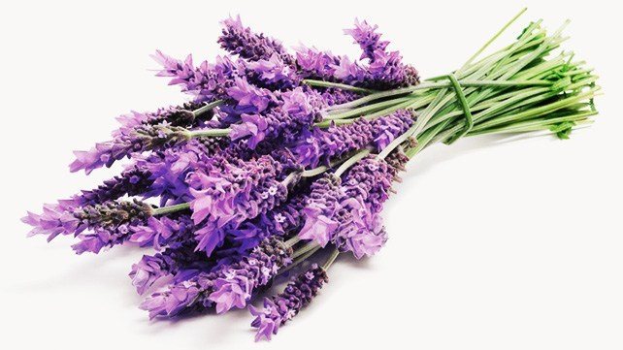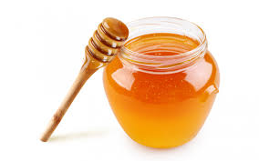

You will need

- Most importantly approx. 1 hour of your time in which you will be undisturbed so you can follow along and make your potions
- 2 x Himalayan pink rock salt grinder 360g or approx. 500g loose Himalayan pink rock salt. The salt should be rocks, rather than ground.
https://www.bmstores.co.uk/products/world-of-spice-himalayan-salt-spice-grinder-390g-275630
- Olive oil 100mls
https://www.bmstores.co.uk/products/don-mario-extra-virgin-olive-oil-500ml-248352
- Lavender essential oil or any other ‘relaxing’ essential oil such as ylang- ylang, Chamomile, Orange, Lemongrass or Neroli
https://www.boots.com/botanics/botanics-aromatherapy/botanics-peaceful-night-pure-essential-oil-lavender-20ml-10264131
- 1 x large orange or lemon (unpeeled)
- Jar solid coconut oil 500mls (this should be left solid not melted)
https://www.homebargains.co.uk/products/11633-100-organic-virgin-coconut-oil-12-x-500ml-jars.aspx
- Granulated sugar 5 tablespoons approx
- Caster sugar 5 tablespoons approx.
Brown or white sugar is fine, if you only have one type of sugar this is also fine.
- 1x Avocado
- Honey 2 tablespoons approx.
- Few handfuls of oats or oat bran
- X2 medium sized glass airtight containers. Jam jars are perfect or you can buy mason jars or Kilner clip jars cheaply, see below.
If using a jam jar, you should soak it the night before and remove labels so it is ready to use. It’s up to you how simple or aesthetic you want your container to be.
https://www.bmstores.co.uk/products/medium-glass-clip-lock-jar-320255
https://www.therange.co.uk/cooking-and-dining/glassware/jars/my-home-glass-jam-jar/#126691
- Bowl x 1
- Fork
- Spoon x 2
- Empty clean spray bottle
- Sharp knife
- Grater
- Twine or ribbon
- Tags or labels
https://www.bmstores.co.uk/products/tie-on-tags-20pk-344468
- Pen

Disclaimer
Carers of East Lothian DIY tutorial is for entertainment purposes only. Please do not attempt any of these DIY remedies as a substitute for medical advice. If you are experiencing any health problems, please seek medical attention. Please do not attempt using any of the DIY natural remedies if you are allergic or have very sensitive skin. Carers of East Lothian cannot be held responsible or liable for any adverse reaction or injury you may experience as a result of participating.

