**Workshops and Events for Carers - East Lothian - Autumn 2015**

**Please call to confirm and book a place**

|  |  |  |  |
| --- | --- | --- | --- |
| When? | Where? | What? | Run by Whom? |
| 16th Sept  10.30 to 2  Repeated on 30th Sept | MECA  Musselburgh | **Transitions**  A workshop for parents and carers of disabled young people who are transitioning from children’s to adult services.  Lunch Included. | **LCiL**  Call Emma Wynack on 0131 475 2554 for more info and to book a place |
| 23rd September  10 to midday | Bleachingfield Centre (Rm 1)  Dunbar | **Sleep Counselling**  Parent Sleep Awareness Workshop is to gain a basic awareness of children’s sleep and good sleep practice. Including What do you know about sleep? | **Organised by CoEL**  Sessions will be run by Marie Leitch from NHS Lothian  To book call 0131 665 0135 |
| 24th September 10 to 3pm  Lunch included | Brunton Hall,  Musselburgh | **Everyone Together**  An opportunity to explore some of the potential that Self-Directed Support brings. The session will also share stories about some of the small changes that have made big differences for people in different parts of Scotland and locally stories. | **Diversity Matters**  Contact Shirley Cusack for more info and to book a place on 07723408764 or e-mail shirley@keystoinclusion.co.uk |
| 6th Oct  4.30pm to 6.30 | Port Seton Centre,  Port Seton | **Carers Laughter Session**  Something completely different! As seen in the Daily Record and Independent on Sunday. Laughter to boost health and happiness. | **Organised by CoEL**  Sessions will be run by Jo Bluett - Laughter for Health  To book call 0131 665 0135 |
| 7th Oct  10 am to 1pm  Lunch included | Trinity Centre Haddington | **What you need to know about legal Guardianship – young people**  Issues facing parents & carers when a child becomes and adult and guardianship is required | **Organised by CoEL**  Sessions will be run by Gillian Brown, Partner in Morrisons LLP  To book call 0131 665 0135 |
| 21st Oct  10am to 1pm  Lunch included | CoEL Offices,  94 High Street,  Musselburgh | **What you need to know about legal Guardianship - adults**  Issues facing carers when an adult loses capacity and there is no Power of Attorney | **Organised by CoEL**  Sessions will be run by Gillian Brown, Partner in Morrisons LLP  To book call 0131 665 0135 |
| 27th October  10am-12 | Prestonpans Community Centre | **Hand Reflexology**  Using reflexology to help manage pain, reduce stress and boost immunity | **Organised by CoEL**  Session being run by Geraldine McCulloch  To book call 0131 665 0135 |
| 4th Nov  10.30 to 12.30  Or  3rd Nov  5 weeks | Bleachingfield Centre, Dunbar  Or  CoEL Offices, Muss | **Support sessions for people caring for someone with dementia**  Sessions will run for 5 consecutive weeks and focus on helping carers cope with the challenge of caring for someone with dementia – see over for details | **Organised by CoEL and Catriona George – Clinical Psychologist.**  Contact Catriona on 07710 866751 for more info or to book |
| 3rd & 12th November | MECA  Musselburgh | **Managing a Direct Payment and Employing Personal Assistants**  Two sessions focusing on different aspects of working with PAs and managing direct payments. Attend one or both. | **LCiL**  Call Amanda Beech on 0131 475 2350 for more info and to book a place |
| 19th Nov  11-1 | Port Seton community Centre,  Port Seton | **Dealing with Challenging Behaviour**  Training session for parents/carers of young people/children with Autism or Learning difficulties | **Organised by CoEL**  Sessions will be run by Simon Robinson from Barnardos  To book call 0131 665 0135 |

 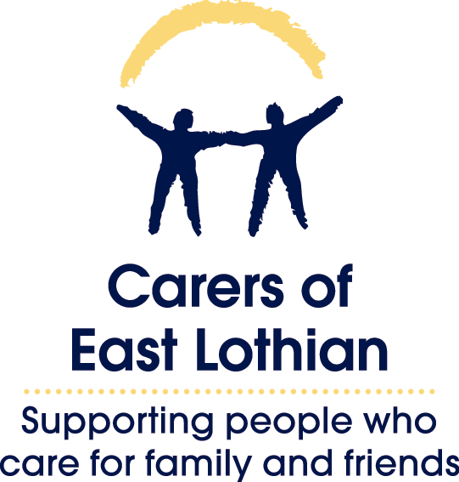 

**Support sessions**

**for people caring for someone with Dementia**

There will be two parts to these series of support sessions for carers. Firstly developing carers’ understanding of the behavioural changes that can be caused by dementia in order to help them develop ways to manage these. Secondly, we will use an Acceptance and Commitment Therapy (ACT) approach to help carers come to terms with the difficult aspects of being a carer and to find ways to cope with the negative thoughts and emotions that accompany this. These sessions will be informal and relaxed and will allow carers to meet up with other people in similar circumstances.

**These sessions will be run in two locations – choose which is best for you**

**Wed 4th Nov to Wed 2nd Dec**

**10.30am to 12.30pm**

**Carers of East Lothian Offices**

**94 High Street, Musselburgh, EH21 7EA**

**Tues 3rd Nov to Tues 1st Dec**

**10.30am to 12.30pm**

**Bleachingfield Centre**

**Dunbar, EH42 1DX**

**The sessions run over 5 consecutive weeks and carers are asked to try to commit to attend all the sessions to get the most benefit from them.**

Sessions will be run by Catriona George – trainee Clinical Psychologist.

**Contact Catriona on 07710 866751 for more details or to book a place**

Participants will be asked to complete some questionnaires before and after the sessions to help evaluate their impact.