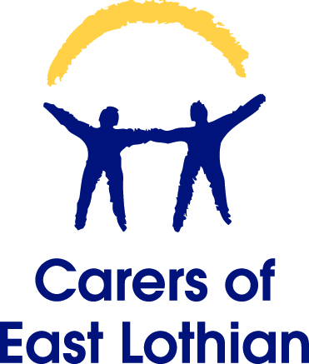

Who Cares for Carers?
- Do you care for a family member, partner or friend and live in East Lothian? Then why not come along to our free five week information & training sessions
- These sessions will be at our offices in Musselburgh – 94 High Street.
- The sessions will cover topics such as: Advocacy, Benefits, Managing Stress and Relationships. You will also get a chance to try an alternative therapy, learn some gentle exercise techniques and hear about services available in the local area.
- All 5 sessions will be on a Tuesday @ 10am – 12.30pm and will be followed by a free light lunch
- A great chance to meet other carers in a similar situation.
- Our first session starts on Tuesday 3rd March 2015.
To book your space please contact Sharon or Lynne @ Carers of East Lothian on 0131 665 0135 or email sharon@coel.org.uk
Carers of East Lothian may be able to assist with transport and sitter costs to enable you to attend the course. Please enquire when booking your space.
Carers of East Lothian supports all adults in a caring situation in East Lothian to get information and services to help their individual caring role, enhance their own wellbeing, and strengthen their collective voice to improve services. Carers of East Lothian is a charity registered in Scotland Charity No. SC027000. Company Limited by Guarantee, No. SC366908

